# Introduction to TM 2.0

Traffic Management 2.0, in short “*TM 2.0”* or often referred below as *“TM 2.0 concept”*, stands for a new proven collaborative concept for Traffic Management and Controls, in which the travellers and goods, through the use of new technologies and sensors, become entirely part of the data supply chain. It offers great new opportunities for Traffic Management and Control making it, on one side, cheaper and more efficient for the road operators, and, on the other side, more friendly and acceptable for the users.

The *“TM 2.0 Platform”* is an open group established by 40 public and private actors from the global traffic management and mobility service market who joined forces driven by the common vision and belief to “Enable vehicle interaction with traffic management”.

## Raison d’etre

The traffic management industry offers well-proven ITS solutions for improving traffic flow and safety using a large diversity of sensors along the roads. Traditional traffic data collection and monitoring (e.g. flow, speed, acc.), including floating car data, is a mature technology with a clear business model.

Current navigation systems in the vehicles use traffic information to provide singular route advices to the drivers, missing however the information related to traffic circulation strategies, traffic regulations or prioritized routes put in place by the Traffic Management Centres. This is especially the case when notable events are foreseen (planned or unplanned), such as important sport or cultural events, demonstrations, constructions or public transport strikes, but also when specific plans need to be enforced, e.g. in cases of smog warnings, evacuation alerts, sudden diversions due to accidents or natural hazards, or low-emission zones.

The future of traffic management is to combine intelligently the individual driver objectives (individual users’ optimization) together with network wide management strategies (system optimization and equilibrium) in a win-win scenario. In Figure 1 the different elements are shown that need to be taken into account along the value chain of the TM 2.0 concept.

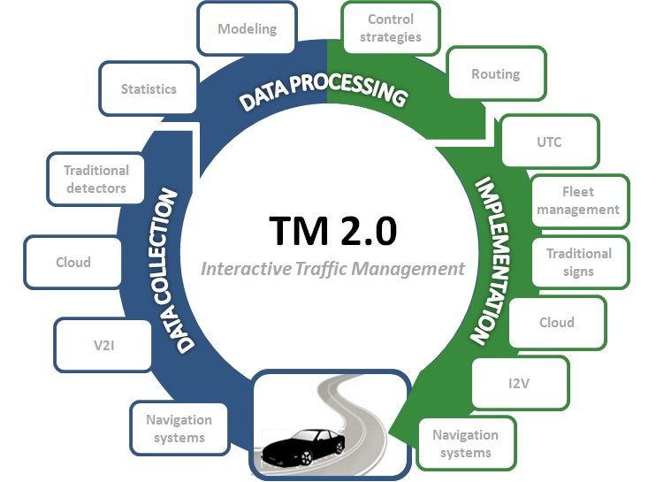

Figure : Element at work along the value chain of the TM 2.0 concept

## Origin and genesis of the TM 2.0 Platform

The need for a stakeholder’s platform on interactive traffic management was originally expressed in 2011 from TomTom and Swarco. With the approval of the ERTICO supervisory board, the two companies were given the mission to establish an attractive platform that would: (1) Act as a facilitator for innovation at the interfaces between different activities and skills areas; (2) Develop, maintain and integrate new and existing activities to operate key enablers or ITS services; (3) Bridge the gap between research and deployment; (4) Integrate existing solutions into one agreed, common and harmonised approach; and finally (5) Maintain and further advance key enablers and ITS services. The platform needed to offer an open, multi-sector, objective-driven collaboration based on interoperable solutions for Europe.

Over the past years, a series of public and private stakeholders in traffic management and service providers joined the efforts to set up this new platform called “TM 2.0”[1].

The TM 2.0 platform was formally established in Helsinki on 19 June 2014 at the ITS European Congress at which 22 founding members have committed to the platform (see Figure 2). Noteworthy, most of the traffic management solution providers are represented together with a good number of public authorities.

|  |  |  |  |
| --- | --- | --- | --- |
| **Public Authorities** | | **Research** | **Traffic & Transport** |
| Austria | Austriatech | CERTH - HIT | Kapsch TrafficCom AG |
| Finland | Finnish Transport Agency | CTAG | Imtech Traffic & Infra (now Dynniq) |
| Norway | NPRA - vegvesen | ICCS | Swarco-Mizar (now Swarco) |
| The Netherlands | Rijkwaterstaat | TNO | Vialis BV |
| Slovenia | Slovenian Ministry of Infrastructure and Spatial Planning | **Service providers** | **Users** |
| Switzerland | Swiss federal Roads office (FEDRO) | ATOS | International Automobile Federation |
| London City | Transport for London | NOKIA/HERE(now HERE) | RACC |
| **22 founding members** |  | TomTom | **Vehicle Manufacturer** |
|  |  | **Supplier** | BMW Group |
|  |  | CONTINENTAL |  |

Figure : TM 2.0 founding members

As a multi-sector and open initiative, the group is bound to grow and form a critical mass of public-private actors ultimately agreeing on the modus operandi of the way we will achieve true interactive traffic management and control.

## Vision of the TM 2.0 platform

Traffic Management 2.0, TM 2.0, is an open group of significant actors from the global traffic management and mobility service market who joined forces driven by the common vision and belief to

**“Enable vehicle interaction with traffic management”**

inevitably leading to the faster development of individual mobility services, and to the improved effectiveness of accurate and efficient traffic management and control becoming integrated with the growing use of navigation systems inside the vehicles. Figure 3 shows the TM 2.0 vision to enable the interaction between vehicles and traffic management.



Figure : TM 2.0’s vision to “Enable vehicle interaction with traffic management”

## Objectives

The overall objective of TM2.0 is to provide a discussion forum around the topic of interactive traffic management for all relevant stakeholders, in the entire Traffic Management Procedure value chain.

**The TM 2.0 objectives are following a phase loop:**

* **Phase I ( TM2.0 value chain definition)**
* **Phase II ( TM2.0 value chain creation)**
* **Phase III ( TM 2.0 marketplace implementation)**
* **Phase IV (TM 2.0 Innovation Procurement)**

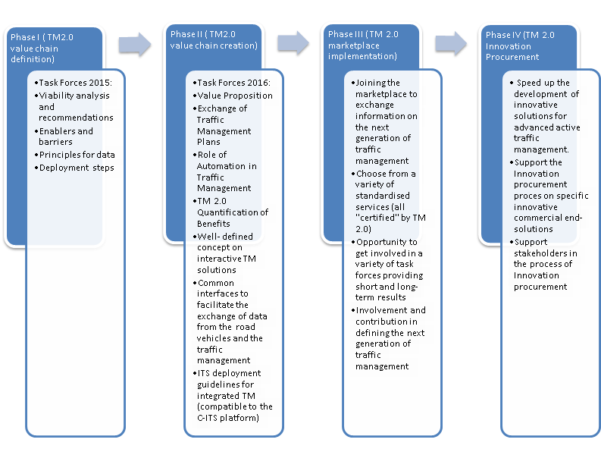

TM 2.0 is now focusing on the next phase III and IV objectives:

* Further work on the **Exchange of Traffic Management** which will be focusing on the ‘why’ and the communication between Traffic management centres and Service providers.
* Further work on the role of **in Automation** in Traffic Management (especially addressing **Needs and requirements towards an infrastructure classification scheme).**
* Speed up the development of innovative solutions for advanced active traffic management by linking to **intermodal and syncromodal interfaces**.
* Establish **synergies with activities and Platforms**. Digital Transport Infrastructure, MaaS Alliance, TISA) and projects (CO-GISTICS and Socrates 2.0).
* Suggest elements facilitating **contractual agreement** and schemes facilitating win-win cooperation and development of **Business Models** for the relevant stakeholders.
* Speed up the development of innovative solutions for advanced active traffic management by supporting the TM 2.0 Innovation **Procurement** process
* Implementation of the TM 2.0 a **market place** focussing on new solutions for advanced active traffic management.
* Continue contributing with **guidelines** and r**ecommendations**

## Mission of the TM 2.0 platform

The future of Traffic Management is to build upon deployment of connected vehicles and travellers in order to:

* achieve convergence of mobility services and traffic management,
* create synergies between actions of the individual travellers with the collective mobility objectives,
* bridge the innovative developments in the vehicle and in the traffic management while giving value to the legacy and creating new business opportunities.

## Scope of the TM 2.0 platform

The scope of TM 2.0 includes business models, deployment steps, public-private cooperation concepts, organisational architecture, data exchange principles and other relevant aspects related to the interaction of the following services:

* Mobility services (Individual routing, Individual information and advice, High quality real time and reliable services, Interface to other modes of transport)
* Road traffic management (Traffic management and control strategies, Collective routing, Adaptive and dynamic Traffic control, Traffic Management Procedures, Interface to other modes of transport)
* Data collection (Privacy, Security and data collection, Journalistic, Static and dynamic data, Probing, Dynamic Location Referencing, Update of the Local Dynamic Map)
* Legacy and evolution of current systems (Integration of traditional and probe data)

Adoption of specifications and standards, use of specific communication technologies and Vehicle-to-Vehicle (V2V) communication are NOT in the scope of TM 2.0 unless the stakeholder cannot find the relevant body to liaise with.

## TM 2.0 Governance

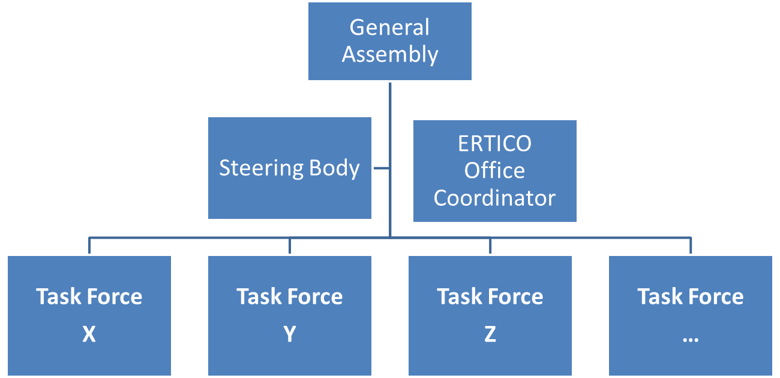

## Organisation of the Work

TM 2.0 sets up yearly Task Forces to study different key topics related to interactive traffic management and MNM. The Task Forces examine and clarify aspects of the concept and practice of TM 2.0 and MNM and their recommendations are accessible to the public. All reports from past Task Forces can be found on our [website](https://tm20.org/final-reports-on-task-forces/).

## Cost of membership



Micro-enterprises (**less than 20 employees**) have a reduction of 50% of Annual / Entry Fee.

ERTICO members are entitled to a reduction of 50% of the membership fee.

A Public Authority or Road Operator in charge of road operation on part of the European road network is exempt from paying membership fees according to the decision of the TM 2.0 platform Steering Body members.

## Procedure to become member

Interested parties are welcome to express their interest to become member by filling in the Expression of Interest (EoI) form in the annex 1.

The TM 2.0 Steering Body will consider your EoI application and give a feedback within 3 weeks. The TM 2.0 Secretariat will send out the formal reply soon after.

# Annex 1: Expression of Interest (EoI) for TM 2.0 membership

[name of legal entity], represented for the purpose hereof by [name and title of person written out in full (person legally authorised to act on behalf of the legal entity)] acting as its legal authorised representative, hereby expresses its interest to become a full member of the TM 2.0 platform.

I am aware that my Expression of Interest (EoI) is subject to the approval of the TM 2.0 Steering Body. I accept to pay the following TM 2.0 membership fees:

|  |  |  |  |  |
| --- | --- | --- | --- | --- |
| **Column1** | **ERTICO Partners** | **Column2** | **Non ERTICO Partners** | **Column3** |
| **Founding Members** | **2000€ Annual/Entry fee** | | **x** |  |
| **Public Authorities** | **No fee** |  | **No fee** |  |
| **New joining Members (2016, 2017)** | **2000€ Annual fee 2000€ Entry fee** |  | **4000€ Annual fee 2000€ Entry fee** |  |
| **Associate Members (optional)** | **Entry fee** | **500€/year with no voting rights** | **Entry fee** | **Annual fee** |

Micro-enterprises (**less than 20 employees**) have a reduction of 50% of Annual / Entry Fee.

I am aware that such fees are not reimbursable.

**Motivation for membership at TM 2.0**

Please shortly describe your motivation to contribute to the work of the TM 2.0 platform:

|  |
| --- |
|  |

**ERTICO Partnership member**

**Please indicate if you are a member of the ERTICO Partnership:**

* Yes
* No

**ERTICO Sectors (also applicable to non-ERTICO Partnership members)**

**Please indicate the main sector of activity of your organisation:**

* Traffic & Transport
* Service providers
* Public Authorities
* Vehicle Manufacturers
* Suppliers
* Other ERTICO Sector: .......

**Competences covered by the work of TM 2.0 platform**

**Please indicate how you / your organisation could contribute to the TM 2.0 platform activities:**

* Traffic management centres especially dynamic traffic control
* Intersection and section control
* In-vehicle navigation
* Local and regional policy support
* C-ITS and applications over Local Dynamic Maps
* Machine-to-Machine (M2) and Internet of Things (IoT)
* Connected vehicles and connected devices
* Telecommunication technologies (3G, LTE, 5G, V2X, Digital Broadcast, etc…)

Name of Legal Entity:

Name of legally authorised representative: (written out in full)

Title of legally authorised representative:

**Company administrative details:**

email: Phone:

Address:

Post code Country

VAT registration number: .

**Primary contact person in our organisation to participate in TM 2.0 activities:**

Lastname: Firstname:

eMail: Phone:

Date: …………………………

Signature of legally authorised representative:

# Annex 2: ERTICO Platforms:

# Purpose of ERTICO platforms:

The purpose of ERTICO platforms is to facilitate innovation at the interfaces between different ITS sectors by bringing together the relevant stakeholders. The cooperation aims to increase competitiveness across the ITS sectors and set the grounds for a healthy market. The cooperation should help to rapidly close the gap between the research, innovation and deployment cycles by agreeing across sectors on the steps and milestones. Whenever relevant, the cooperation should make sure the proposed solutions respect the existing solutions among the platform sectors and convergence paths towards integrated solutions are foreseen.

# General Principles governing ERTICO platforms

The following general principles apply to the ERTICO Platforms:

* **Partnership initiative:** An ERTICO Platform is an activity initiated by ERTICO Partners and therefore considered as an ERTICO Partnership activity
* **Multi-sector cooperation**: Minimum two ERTICO partners from at least 2 different ERTICO sectors should initiate platform proposal idea,
* **Clear Objectives:** An ERTICO Platform is constituted to fulfil clear wishes and goals of the participating parties,
* **Coherence:** Topic(s) addressed by platform proposal should be in line with ERTICO Partnership priorities,
* **Openness:** An ERTICO Platform membership is open to ERTICO Partners as well as Non-ERTICO Partners,
* **Self-Financed:** An ERTICO Platform budget and financing scheme should secure enough financing from first year of operation phase,
* **ERTICO Office support:** An ERTICO Platform is managed, coordinated and organised by the ERTICO office,
* **Interoperability:** Proposed approach should promote interoperability through the creation of open and harmonised specifications and eventually standards,
* **Geographic Scope:** Proposal should address as a minimum European market.

1. <http://tm20.org/>